Project Documentation

CSE 310

Wei Tang

Stephen Egert

Overview

As for now, we have implemented both stage one and stage two. Major implementation includes type, done, help, put, get, del, browse and exit. Please notice that after stage two implementation, we have dropped all type fields in command.

type [t] return the port number of the DNS server of t type and establish TCP connection between client and DNS server. Return not found if no DNS with given type.

done close current TCP connection with DNS server and establish connection with manager application

help print help message

put [name] [IP addr] put command will put a DNS record with name field, ip address and the type assigned to this specific DNS server.

get [name] get command will return the IP address of the given name, return not found if no record with given name is founded.

del [name] del command will delete the record in the DNS server with the given name. return not found if no record with given name in database

browse browse all the record in the database within the current DNS server.

exit close TCP connection. Client application exits.

User documentation

Our implementation using threads class for concurrency between client to both manager application and DNS server. We never tested the limitation of the program, but it can definitely support more than 5 name servers.

To compile manager application (Server side):

javac manager.java

To run manager application:

java manager.java

To compile and run client side code

javac TCPClient.java

java TCPClient <hostname> 5858

(Our implementation of manager application is on port 5858)

Once the connection between manager and client established client will promote user to input command, at this stage only command help, type[type] and exit can be used (because now the client is connected to manager not a DNS server)

Example for connect to type N DNS server:

*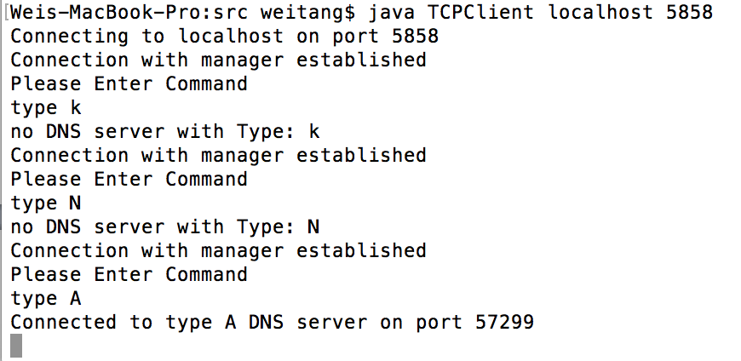*

Possible error message here would be “no DNS server with type found” or “unknow manager command” for wrong command

Once connection between a DNS and client is established then all other function is now available to user (browse, get, del, done and help)

Example for a sequence of command:

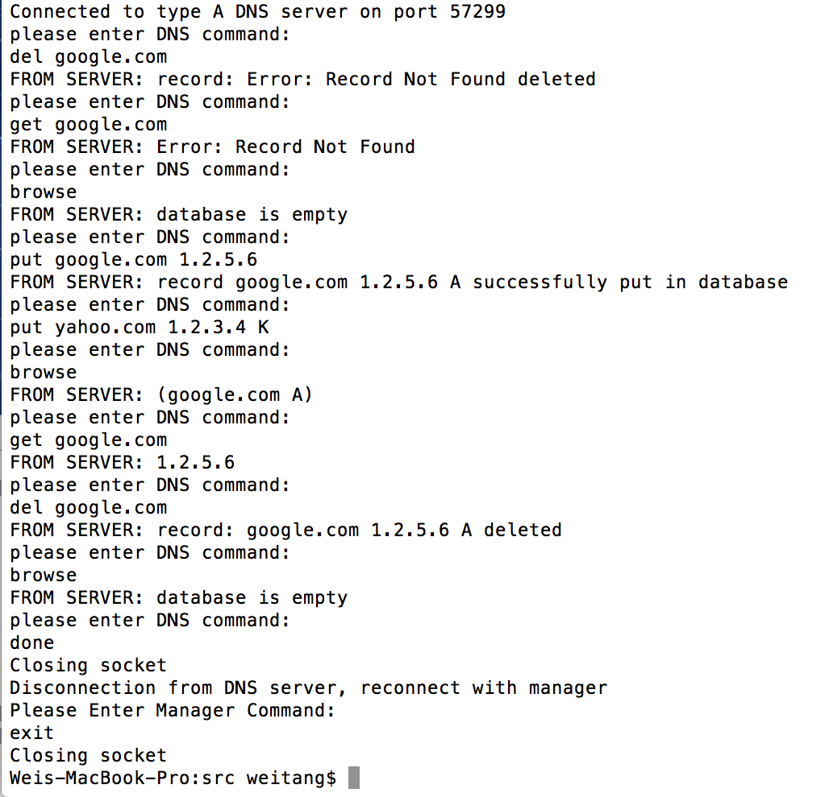

possible error message:

“Database empty” for empty database

“record not found” for no matching record in database for both get and del

notice that in the sequence put yahoo.com 1.2.3.4 K. this command does not put the record to the data base because we drop the type field in the command which make it an illegal command.

Once user enters done, connection between DNS and client will be closed and establish new connection to manager for using other DNS servers.

System documentation

Testing documentation